Server (Windows, PXI)

<https://github.com/chericksgit/Tesla-LRMS>

1. Open NI Package Manager and verify LabVIEW 2019 32-bit is installed
   1. If not installed, then install LabVIEW and Drivers
      1. 2019 32-bit version
      2. Include NI-DCPOWER, NI-DMM, and NI-SWITCH
      3. Include anything else you want

1. Configure MAX device descriptors to appear like the following picture:

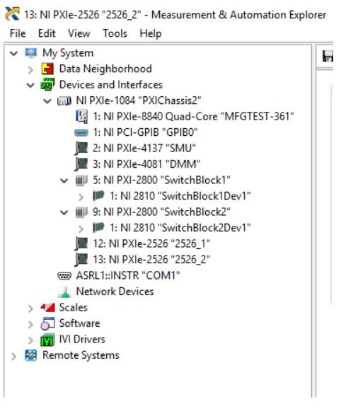

1. Download the repo. The LabVIEW project is located under the following directory once extracted:
   1. Tesla-LRMS-Master/Tesla-LRMS-Master/Tesla-LRMS-PoC/LabVIEW-grpc-measurement-server-master/
   2. The project is named Test.lvproj
      1. The top-level VI is named ExampleMeasurementServer - Hardware.vi

1. Adjust IP address of the controller to be on the same subnet as the NUC.

Server = 169.254.115.152

Client = 169.254.115.153

1. Run the VI.
   1. Use the following as the server address = 169.254.115.152:50051

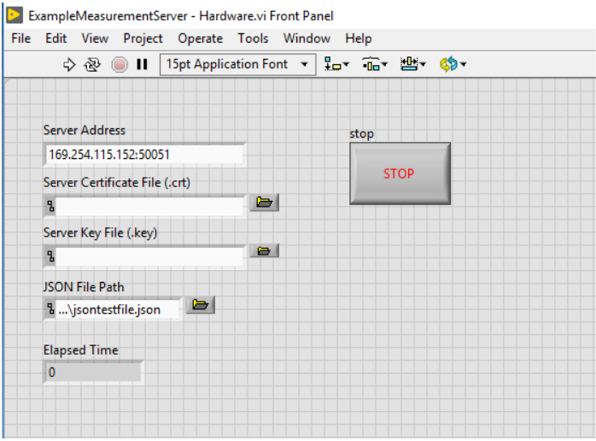

1. On the NUC, navigate to Home/labview-grpc-query-server, and execute the example_client

* ./example_client --target=169.254.115.152:50051

A separate set of instructions will be provided for the Linux RT PXI controller.